Lab No 8 Practical immunity Asst.prof:Tamadher Mohammed

Enzyme Linked Immunosorbent Assay

The enzyme-linked immunosorbent assay (ELISA) is an immunological assay commonly used to measure antibodies, antigens, proteins and glycoproteins in biological samples. Some examples include: diagnosis of HIV infection, pregnancy tests, and measurement of cytokines or soluble receptors in cell supernatant or serum.
ELISA assays are generally carried out in 96 well plates, allowing multiple samples to be measured in a single experiment. These plates need to be special absorbant plates (e.g Clear polystyrene plates) to ensure the antibody or antigen sticks to the surface. Each ELISA measures a specific antigen, and kits for a variety of antigens are widely available.
•It is Quantitative
• Very sensitive
•Commonly used in medicine, vet. medicine and scientific research.

- Uses of ELISA
- 1-Laboratory diagnosis of almost all infectious diseases in humans, animals and plants.
- -Detection of antitoxins. 2
- Detection of allergens in food, e.g. peanuts.3
- 5-Measurement of hormones
- 6Detection of illegal drugs in humans.

Materials needed in ELISA Testing
* ELISA coated plate (microtiter plate),ELISA Reader
* washers and pipette are available as manual or automated system. ...
*Reagents Concluded in the kit : sample diluents, controls, wash concentrate, conjugate, substrate, enzymes, stop solution, Standard buffer, Coating buffer, Blocking buffers, Washing buffers.
Antibodies(serum sample)*
- Enzymes used in ELISA
- *Horseradish Peroxidase ( Yellow , Substrate= TMB)
- *Alkaline phosphatase from E. coli (ABTS)) Green
Basic steps of ELISA
1- Bind the antigen to the plate.( 2-3 times washing to remove unbound antigen)
2- Block the plate to get rid of any non-specific binding sites .
( 3 times washing to remove unbound Blocker)
3- Incubate with the (tested serum) primary antibody
( 3 times washing to remove unbound antibodies)
4- Add the conjugate (the Secondary antibody that is linked with an Enzyme is allowed to bind with the primary antibody).
( 3 times washing to remove unbound conjugate)
5- Use a Substrate for the enzyme, which will cause color to be released.
6- Addition of stopping reagent to stop colour development.
- 7- Reading of the colour intensity
Types of ELISA
1- Competitive ELISA
2- Sandwich ELISA (also called direct ELISA)
3- Indirect ELISA

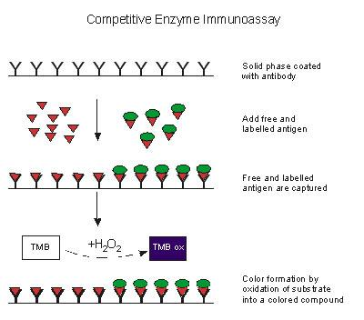

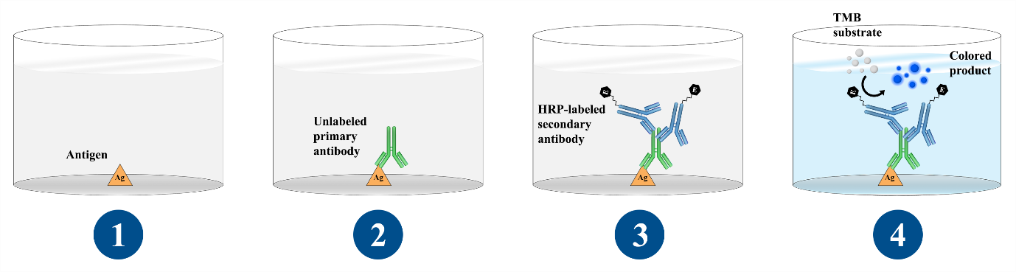
Indirect ELISA

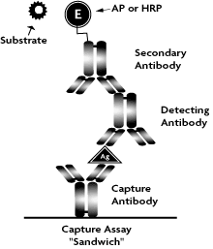
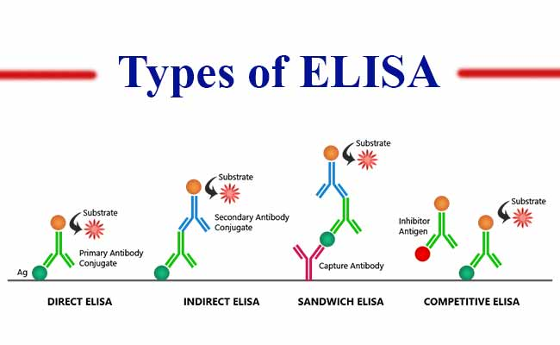

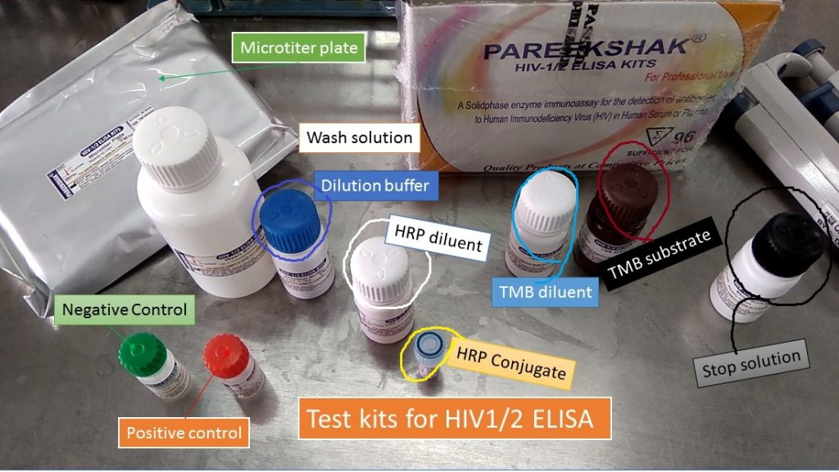
Kit of ELISA test

